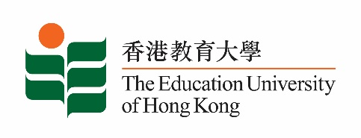
致： 传媒机构采访主任 (共 1页) 18 June 2021
To : News Editors (total: 1 pages)

香港教育大学2021年6月21日至7月4日可供采访之活动一览
The Education University of Hong Kong (EdUHK) Events Calendar for 21 June to 4 July 2021
本校诚邀 贵机构派员采访下列活动。传媒查询，请联络教大传讯处（电话：2948 6050）。
You are cordially invited to cover the events below. For media enquiries, please contact the Communications Office at 2948 6050.

因应2019冠状病毒疫情，以下活动或有人数限制，传媒请预先向主办部门登记。
In light of the COVID-19 pandemic, there may be restrictions on the number of participants for the following event(s). Please contact the respective organiser(s) / department(s) for prior registration.

- 教大大埔校园 （新界大埔露屏路十号） / EdUHK Tai Po Campus (10 Lo Ping Road, Tai Po, New Territories)

日期  Date | 时间  Time | 活动  Event | 地点  Venue | 主办部门及公众查询  Organiser &  Public Enquiry | 备注  Remarks
2021-07-03 | 11:00 am – 4:30 pm | 《以A为焦点的STEAM教学》教材分享会  Teaching Material Sharing: An A-focused STEAM Teaching | 在线讲座  ZOOM  (连结将于报名后经电邮发送)  (Zoom link will be provided via email after registration)  报名方法 / Registration:  https://forms.gle/sosVvy1ZVzCkF4bbA | 主办部门 / Organiser:  教大文化与创意艺术学系  Department of Cultural and Creative Arts of EdUHK  查询 / Enquiries:  钟小姐Miss Zhong  电邮 / Email:  szhong@eduhk.hk  电话 / Tel:  2948 6883 | 欢迎视艺科及对STEAM有兴趣的老师参与；教材书数量有限，先到先得，送完即止。  Visual Arts teachers and teachers who are interested in STEAM are welcome to join. Limited copies of teaching materials are available on a first come first served basis.

